Incorporated 1872
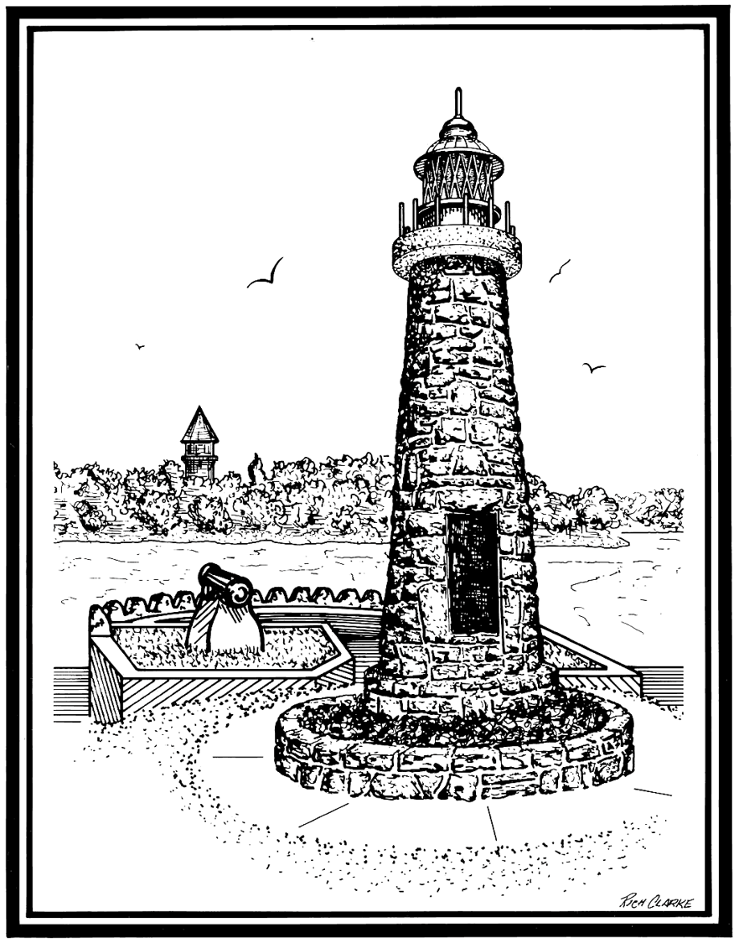

VILLAGE OF CLAYTON

425 Mary St. PO Box 250 Clayton 1000 Islands New York 13624
Phone: (315) 686-5552 Fax: (315) 686-2132
TTD: 1-800-662-1220

RESOLUTION NO. 2023-01
Restore NY Funding Program

WHEREAS, The Village of Clayton is working with the Clayton Local Development Corporation, Ltd. to apply to the Restore NY funding program.
WHEREAS, The Application is for Restore NY funding to rehabilitate the property located at 537 Riverside Drive, Clayton NY, which is owned by Marsha Ringer Topa.

WHEREAS, The Village of Clayton finds that the proposed project is consistent with the community’s Comprehensive Plan;
WHEREAS, that the proposed financing is appropriate for the specific project;
WHEREAS, that the project facilitates effective and efficient use of existing and future public resources so as to promote both economic development and preservation of community resources; and
WHEREAS, where applicable, the project develops and enhances infrastructure and/or other facilities in a manner that will attract, create, and sustain employment opportunities.
NOW, THEREFORE, BE IT
RESOLVED
The question of the adoption of the foregoing resolution was duly put to a vote on roll call, which resulted as follows:
Mayor Zimmer  Deputy Mayor Hyde | YES  YES
Trustee Buker | YES
Trustee Randazzo | YES
Trustee Heberling | YES

The resolution was thereupon declared duly adopted.

