Incorporated 1872
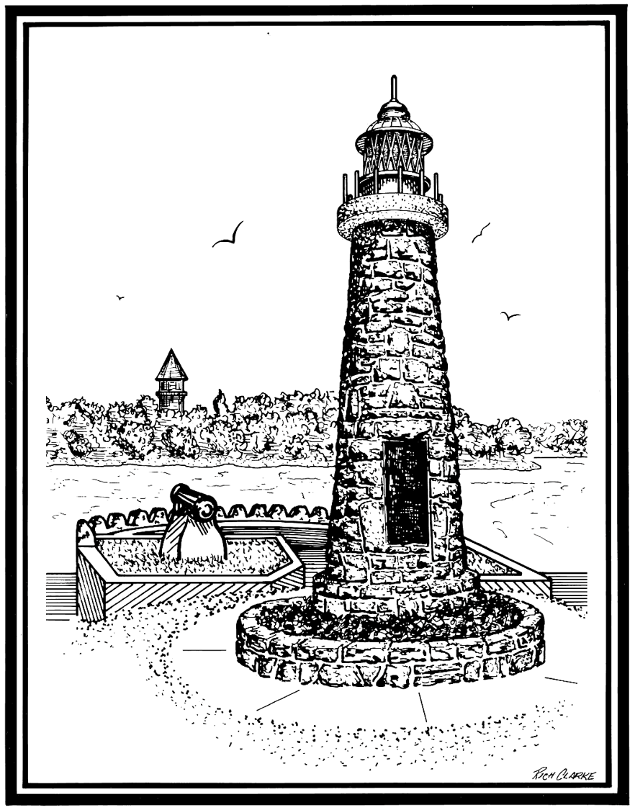

VILLAGE OF CLAYTON

425 Mary St. PO Box 250 Clayton 1000 Islands New York 13624
Phone: (315) 686-5552 Fax: (315) 686-2132
TTD: 1-800-662-1220

VILLAGE OF CLAYTON BOARD OF TRUSTEES
REGULAR MEETING SCHEDULE (2023)

The regular meetings of the Board of Trustees of the Village of Clayton will be held at 5:30 PM in the Village Municipal Building, 425 Mary Street, Clayton, New York, on the 2nd and 4th Monday of every month, as follows:

January 09, 2023
January 23, 2023
February 13, 2023
February 27, 2023 (Joint Mtg. 5:30pm – Regular mtg to follow)
March 13, 2023
March 27, 2023
April 10, 2023
April 24, 2023
May 8, 2023
May 22, 2023
June 12, 2023
June 26, 2023
July 10, 2023
July 24, 2023
August 14, 2023
August 28, 2023
September 11, 2023
September 25, 2023

October 10, 2023 (TUESDAY (Legal Holiday on Monday Oct 09, 2023)
October 23, 2023
November 13, 2023
November 27, 2023
December 11, 2023
December 29, 2023 (9:00 am Village Municipal Building)

2023 Annual Organizational Meeting:
December 4th, 2023

