Incorporated 1872
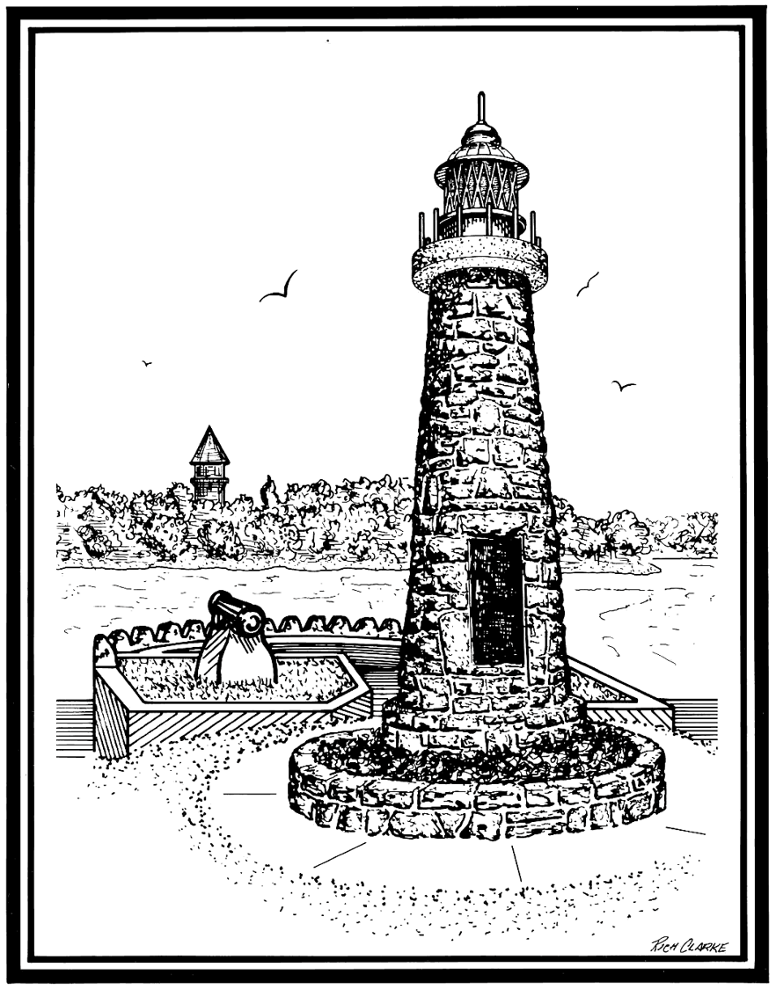

VILLAGE OF CLAYTON

425 Mary St. PO Box 250 Clayton 1000 Islands New York 13624
Phone: (315) 686-5552 Fax: (315) 686-2132
TTD: 1-800-662-1220

VILLAGE OF CLAYTON BOARD OF TRUSTEES
REGULAR MEETING SCHEDULE (2021)

In Accordance with the Governor’s Executive Order for the COVID-19 public meetings, the regular meetings of the Board of Trustees of the Village of Clayton will be held with the “Go to Meeting app” until future updates from the Governor. Virtual meeting will start at 5:30pm, on the 2nd and 4th Monday of every month, as follows:

January 11, 2021
January 25, 2021
February 08, 2021
February 22, 2021
March 08, 2021
March 22, 2021
April 12, 2021
April 26, 2021
May 10, 2021
May 24, 2021
June 14, 2021
June 28, 2021
July 12, 2021
July 26, 2021
August 09, 2021
August 23, 2021
September 13, 2021
September 27, 2021

October 12, 2021 (TUESDAY (Legal Holiday on Monday Oct 11, 2021)
October 25, 2021
November 08, 2021
November 22, 2021
December 13, 2021
December 27, 2021

2021 Annual Organizational Meeting:
December 6th, 2021

