Incorporated 1872
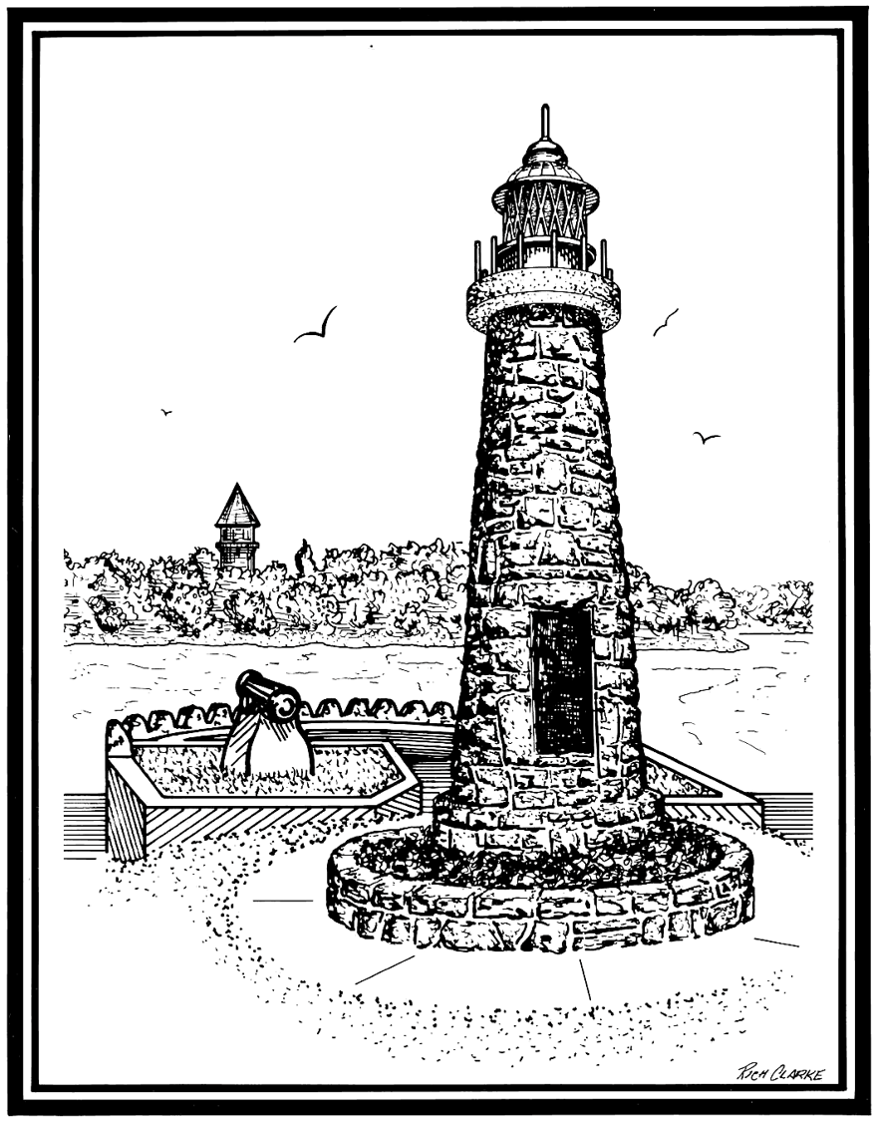

VILLAGE OF CLAYTON

425 Mary St. PO Box 250 Clayton 1000 Islands New York 13624
Phone: (315) 686-5552 Fax: (315) 686-2132
TTD: 1-800-662-1220

VILLAGE OF CLAYTON BOARD OF TRUSTEES
REGULAR MEETING SCHEDULE (2019-2020)

The regular meetings of the Board of Trustees of the Village of Clayton will be held at 5:30 PM in the Village Municipal Building, 425 Mary Street, Clayton, New York, on the 2nd and 4th Monday of every month, as follows:

January 13, 2020
January 27, 2020
February 10, 2020
February 24, 2020
March 09, 2020
March 23, 2020
April 13, 2020
April 20, 2020
May 11, 2020
May 26, 2020 (TUESDAY (Legal Holiday on Monday May 25, 2020)
June 08, 2020
June 22, 2020
July 13, 2020
July 27, 2020
August 10, 2020
August 24, 2020
September 14, 2020
September 28, 2020

October 13, 2020 (TUESDAY (Legal Holiday on Monday Oct 12, 2020)
October 26, 2020
November 09, 2020
November 23, 2020
December 14, 2020
December 28, 2020

2020 Annual Organizational Meeting:
December 7th, 2020

